IdeationPhase Empathize&Discover

Date Team ID
Project Name Maximum Marks
3 December 2025

SHOPEZ : E-commerce Application
4 Marks


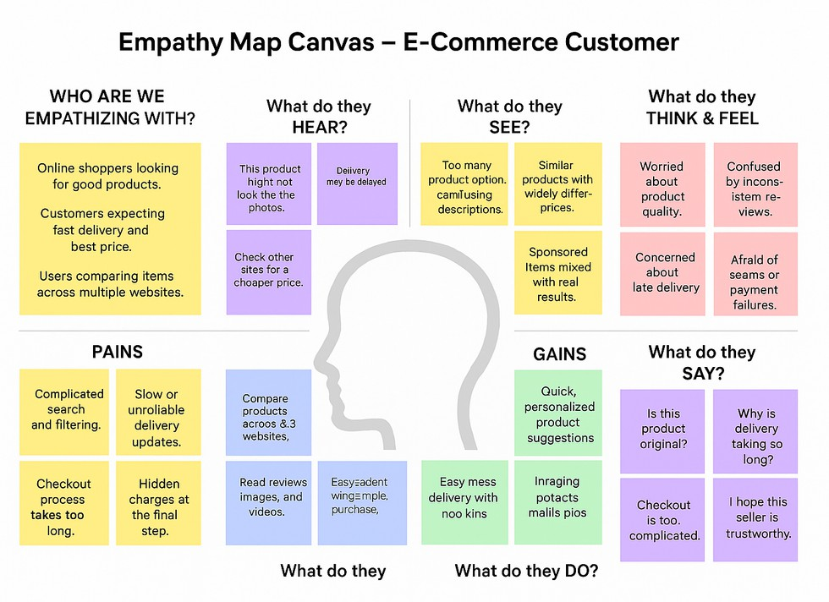
Empathy Map Canvas:

Understand the needs, frustrations, and behaviors of customers who are trying to find the right products, compare prices, check availability, and complete purchases easily through a digital shopping platform.

